**Coding Challenge - Car Rental System – SQL**

**1. Update the daily rate for a Mercedes car to 68.**

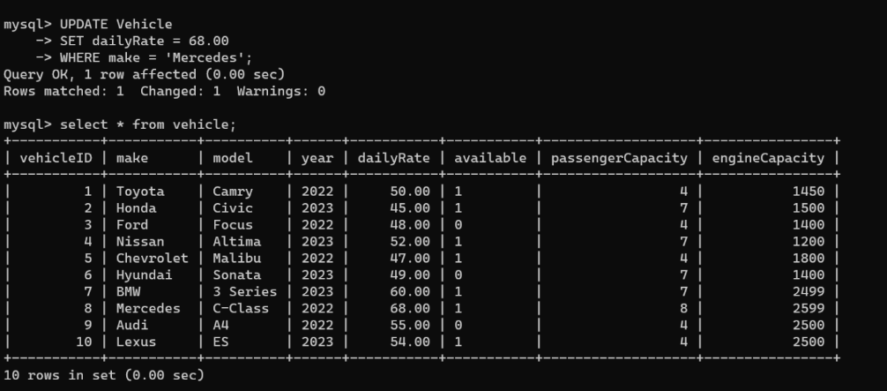

**2. Delete a specific customer and all associated leases and payments.**

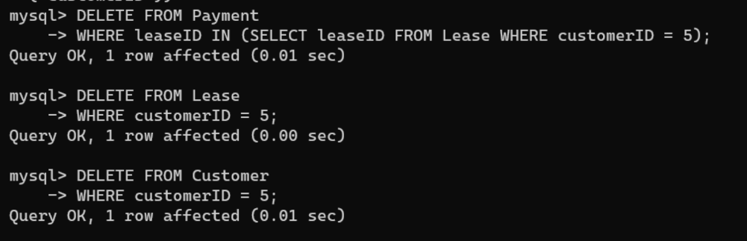

**3. Rename the "paymentDate" column in the Payment table to "transactionDate".**

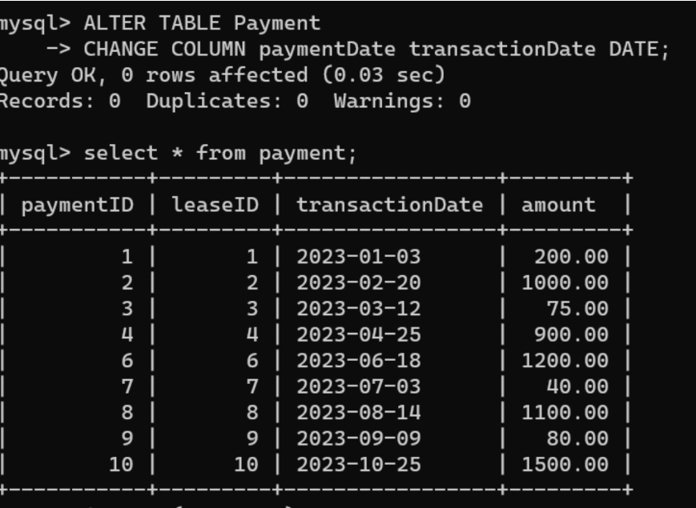

**4. Find a specific customer by email.**

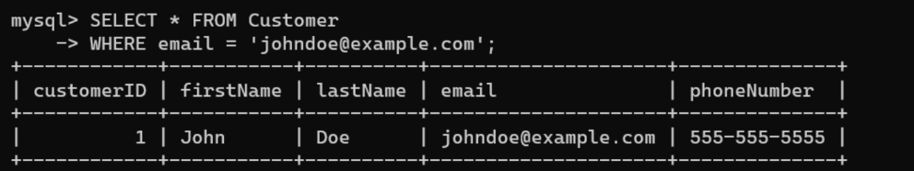

**5. Get active leases for a specific customer.**

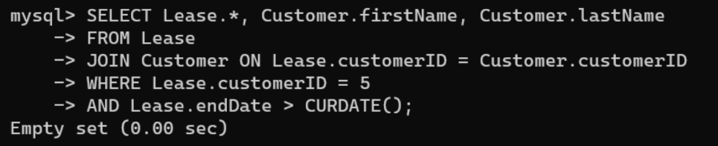

**6. Find all payments made by a customer with a specific phone number.**

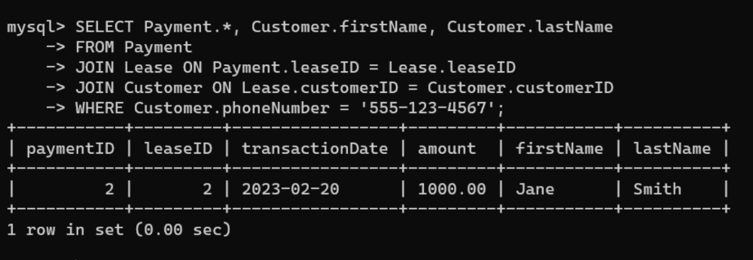

**7. Calculate the average daily rate of all available cars.**

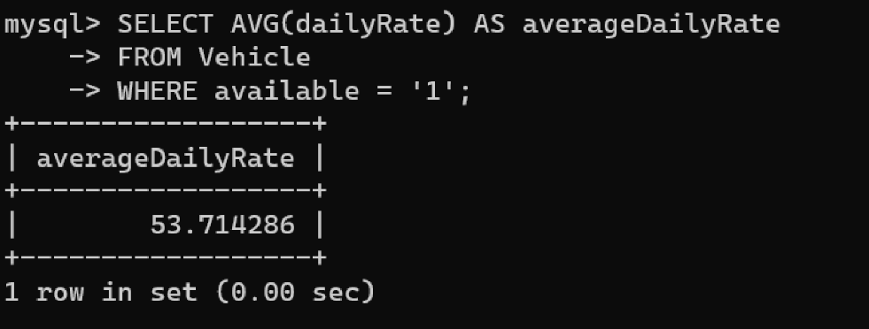

**8. Find the car with the highest daily rate.**

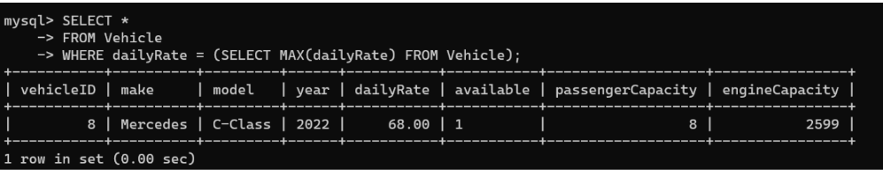

**9. Retrieve all cars leased by a specific customer.**

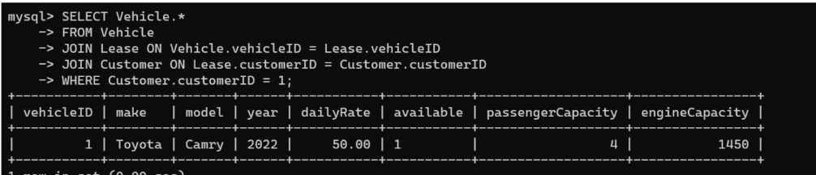

**10. Find the details of the most recent lease.**

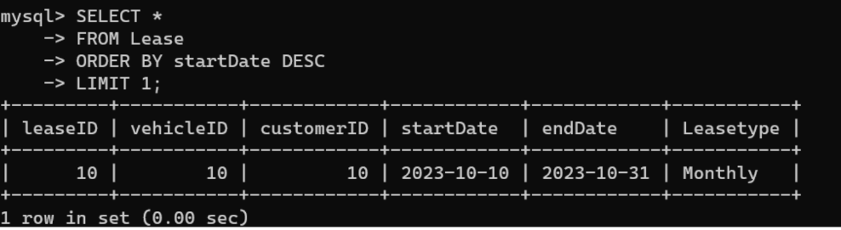

**11. List all payments made in the year 2023.**

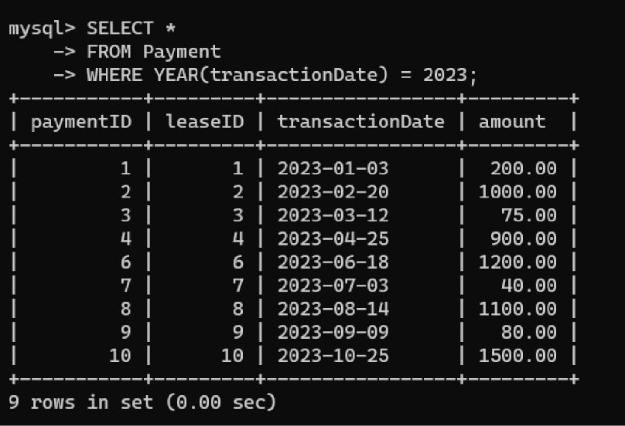

**12. Retrieve customers who have not made any payments.**

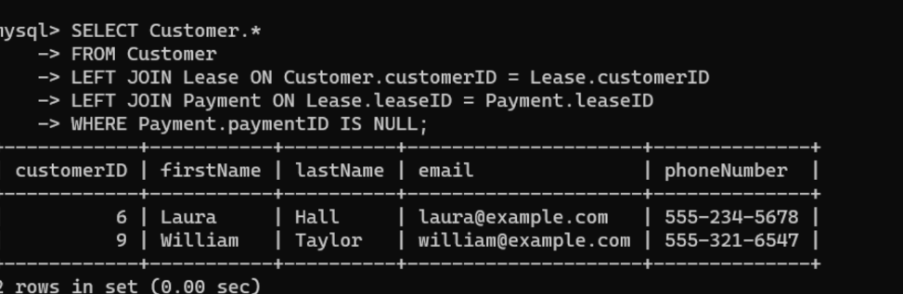

**13. Retrieve Car Details and Their Total Payments.**

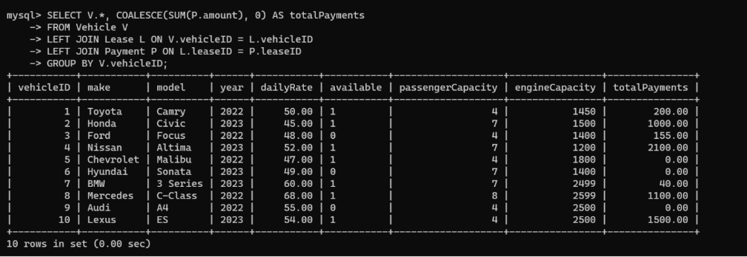

**14. Calculate Total Payments for Each Customer.**

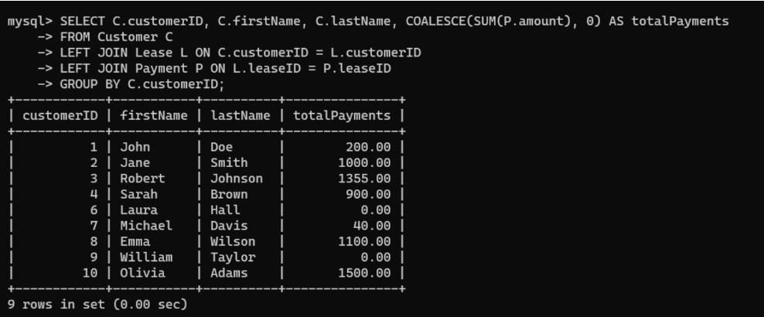

**15. List Car Details for Each Lease.**

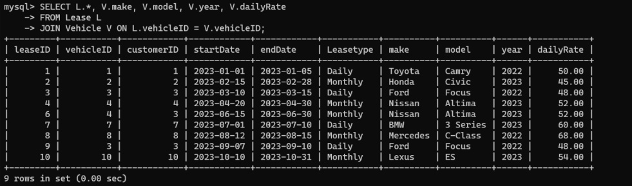

**16. Retrieve Details of Active Leases with Customer and Car Information.**

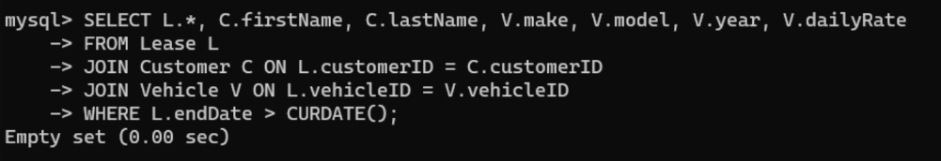

**17. Find the Customer Who Has Spent the Most on Leases.**

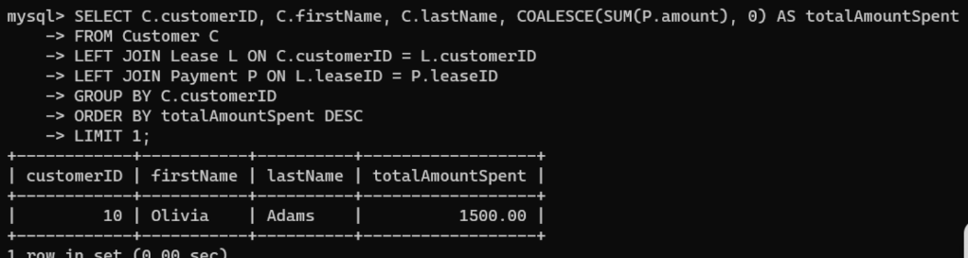

**18. List All Cars with Their Current Lease Information**

